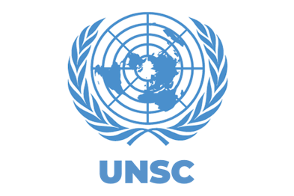

Committee: SC (Security Council)
Preventing the Diversion of Weapons to Non-state Actors and Organized Crime Groups
Director: Fernando Biesek
Moderator: Juan Pablo Valdés
Secretary: Pamela Barrison
INTRODUCTION OF THE TOPIC
The illegal trafficking and transfer of firearms is an important international issue because these weapons can reach organized crime groups, terrorist organizations, and other non-state actors. According to the United Nations Office on Drugs and Crime (UNODC), weapons can be moved from legal markets to illegal ones through theft, illegal transfers, corruption, or weak controls during their transportation and storage (UNODC, 2020). This problem can increase violence, crime, and insecurity in different countries. To prevent this, countries need to work together by improving border controls, keeping better records of weapons, securing weapon storage, and making sure that arms are only transferred to authorized users. International cooperation is therefore necessary to reduce illegal weapons trafficking and prevent weapons from reaching groups that could use them for criminal or violent activities.
BACKGROUND INFORMATION
Weapon trafficking began as an uncontrolled commercial trade alongside the development of gunpowder and firearms in Europe and Asia during the Middle Ages. As firearms became more widely produced and traded, weapons began to cross borders and reach actors (illegal organized groups) outside of government control. Over time, the illegal trade in weapons became increasingly connected to armed conflicts, terrorism, organized crime, and other forms of violence.
CURRENT SITUATION OF THE TOPIC
Today, the diversion of legally manufactured or legally acquired weapons into illegal markets remains a significant international concern. Weapons can be redirected through theft, corruption, illicit transfers, falsified documentation, or inadequate controls over stockpiles and international shipments. Once diverted, they may reach non-state armed groups or organized crime groups, contributing to instability, violence, and insecurity. Furthermore, this uncontrolled flow weakens public institutions, undermines civilian safety, and hinders long-term economic development in affected regions. Weak regulatory frameworks and inconsistent cross-border tracking systems allow arms brokers to exploit legal loopholes, turning domestic stockpiles into lingering sources of regional instability.
Over one billion small arms weapons are sold every year which increases global violence as they supply criminal organizations, cartels, and terrorists. Lasting violence in Ukraine, Sudan and the Middle East keeps massive reserves to keep their ability to bring up conflicts for criminal groups that exploit vulnerabilities but could have ended long ago. Criminals use the Internet, dark web markets, and encrypted messages to traffic weapons. The illegal arms trade continues to be a big problem as it is a billion-dollar industry driven by high criminal demand. These weapons can further exacerbate neighborhood violence and empower criminal organizations.
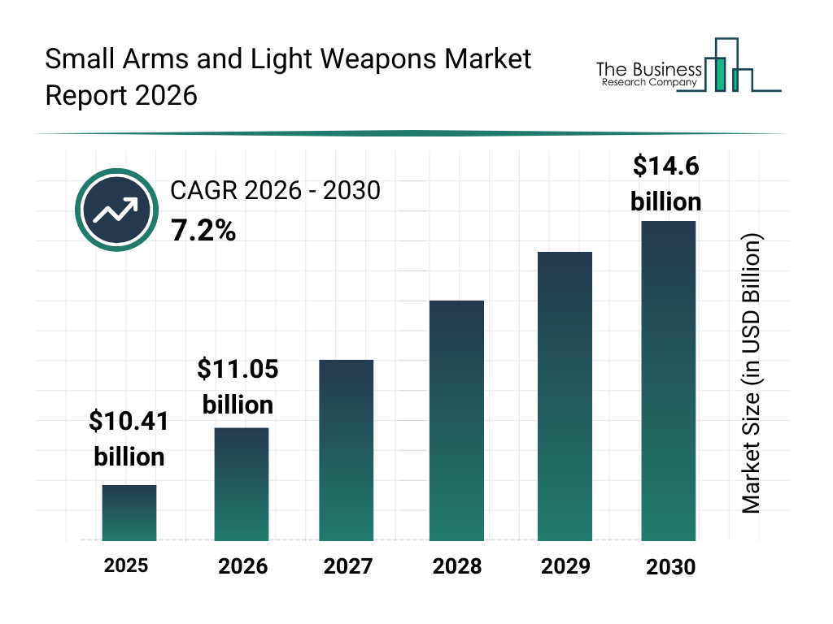
This trade continues to thrive as illegal guns are sold for little initial investment and then resold at higher prices a year after purchase. The billions of dollars that are earned each year from the resale of arms contribute to financing associated world crimes, like the drug trade. Some border officials, customs officers, and even members of the security forces were alleged to be corrupt or to accept bribes in exchange for allowing illicit shipments through without inspection. It makes it more difficult for the government and law enforcement to interdict the illegal weapons that reach criminals. Such a problem alleviation through international cooperation, more stringent border defenses, and tracking of arms transfers.
INTERNATIONAL ACTION ON THE TOPIC
On February 26, the European Commission presented a proposal to combat firearms trafficking and any illegally held firearms. This proposal introduces penalties for firearms crimes and their definitions. This proposal includes the definitions of firearms crimes. The crimes are illegal trafficking of firearms, manufacturing, possession of illicit firearms and essential components and ammunition, changing or removing firearm identification information, and 3D printing arms. It also establishes penalties for each crime. Trafficking and manufacturing of firearms would have a maximum penalty of at least 8 years in prison, the possession of illegal firearms, essential parts, or ammunition would have a maximum penalty of at least 5 years, illegally removing firearms tracking information would a maximum penalty of at least 4 years, and finally 3D printing firearms would have a maximum penalty of at least 2 years. Establishing these laws will ensure that firearms are recognized and punished across the EU.
1

Currently, countries are cooperating through the UN to stop the illegal trafficking of small arms and light weapons. The United Nations Programme of Action on Small Arms and Light Weapons encourages government to keep track of illegal trading of small arms by improving the marking of firearms, data keeping, tracking, border controls, and cooperation between countries. The marking and tracking of firearms are crucial since the law enforcement agencies can use the information to check where the weapon comes from and if it was legally imported or not. This facilitates the process of investigation on how a firearm became illegal. Weapons can be produced everywhere, exported anywhere and used anywhere, so communication is extremely important to stop this issue.
In 2026, the United States and various Caribbean countries also enhanced cooperation to prevent illicit weapons trafficking. The U.S. Department of State stated that the United States is collaborating with Caribbean law enforcement agencies by exchanging important data, doing investigation, and operations aimed at trafficking networks. These measures are followed with the intention of preventing the illegal transportation of firearms and ammunition which can cause more violence and instability.
QUESTIONS TO CONSIDER CREATING A RESOLUTION
- Is your country primarily a manufacturer, exporter, transit point, or destination for small arms and light weapons — and how does that role shape what your delegation can realistically accept in a resolution? Does your country produce arms domestically for export revenue, and what share of GDP or employment does that industry represent?
- Has your country signed and ratified the Arms Trade Treaty, the UN Firearms Protocol, and endorsed the Programme of Action and the International Tracing Instrument? If it has not ratified one of these, what was the stated reason — sovereignty, constitutional protections, national security, or disagreement over scope?
- What does your country's domestic legislation actually require regarding the marking of firearms at manufacture and import, record-keeping periods, licensing of brokers, and penalties for trafficking? Are your penalties comparable to those in the European Commission proposal (8 years for trafficking, 5 for illegal possession, 4 for tampering with markings), or significantly lighter?
- How many firearms are seized annually in your country, where are they traced to, and does your country submit tracing requests to INTERPOL's iARMS or eTrace? If your government does not collect or publish this data, is that a capacity problem, a political choice, or both?
On the causes and the market
- Diversion from state stockpiles — theft from armories, battlefield capture, resale by security forces — is one of the largest sources of illicit weapons. What obligations should states accept regarding physical security and stockpile management, and who should pay for upgrading depots in states that cannot afford it?
- If corrupt customs officials, border guards, and security personnel are a central link in the chain, should an international instrument address corruption directly — and how does your delegation reconcile anti-corruption verification with non-interference in domestic law enforcement?
- Conflicts in Ukraine, Sudan, and the Middle East have created large regional arsenals. What should happen to those weapons after hostilities end, and does your country support mandatory disarmament, demobilization and reintegration (DDR) provisions in peace agreements or post-conflict UN mandates?
- How does illicit arms trafficking interact with other criminal economies in your region — narcotics, human trafficking, illegal mining, wildlife trade? Should arms trafficking be tackled in a dedicated framework or folded into broader transnational organized crime instruments such as UNTOC?
On technology and enforcement
- Traffickers use dark web marketplaces, encrypted messaging, and social media to advertise and coordinate sales. What is your country's position on lawful access to encrypted communications, and can effective enforcement be designed without weakening encryption or privacy protections?
- Polymer 3D-printed firearms, privately made firearms without serial numbers, and conversion kits that turn semi-automatic weapons into fully automatic ones fall outside most existing marking regimes. Should these be regulated internationally, and is your country prepared to criminalize possession of digital blueprints?
- Would your delegation support a National Focal Point model like the one in the EU proposal — a single designated national authority for firearms data and cross-border requests? What would it cost, who would staff it, and would your government accept obligations to respond to foreign tracing requests within fixed deadlines?
- What should the standard be for sharing seizure data internationally — weapon type, model, serial number, point of seizure, suspected origin — and what safeguards would your country demand before sharing law enforcement data with states it does not fully trust?
On the politics of any agreement
- Should a new instrument be legally binding, or is a politically binding framework like the Programme of Action the realistic ceiling? If binding, what enforcement mechanism does your delegation accept — reporting, peer review, sanctions, or nothing beyond voluntary compliance?
- How does your delegation respond to states that argue arms control measures infringe on the right to self-defense, the right of states to acquire arms under Article 51 of the UN Charter, or domestic constitutional rights? Where is the line between regulating the illicit trade and restricting the legal one?
- Who funds implementation? Marking equipment, secure depots, digitized registries, and trained personnel are expensive, and the states most affected by armed violence are often least able to pay. Does your delegation support a dedicated UN trust fund, regional development bank financing, obligations on exporting states, or conditional bilateral assistance — and what accountability comes attached?
RESEARCH AID
Publications and tools. (n.d.). United Nations : Office on Drugs and Crime. https://www.unodc.org/unodc/en/firearms-protocol/publications.html
Modular Small-Arms-Control Implementation Compendium | United Nations Office for Disarmament Affairs. (n.d.). https://disarmament.unoda.org/en/conventional-arms-initiatives/modular-small-arms-control-implementation-compendium
Illicit arms flows data. (n.d.). United Nations : Office on Drugs and Crime. https://www.unodc.org/unodc/en/firearms-protocol/news/illicit-arms-flows-data.html
Firearms trafficking. (n.d.). https://www.interpol.int/en/Crimes/Firearms-trafficking
Illicit Arms Records and tracing Management System (iARMS). (n.d.). https://www.interpol.int/Crimes/Firearms-trafficking/Illicit-Arms-Records-and-tracing-Management-System-iARMS
Unknown. (2020). GLOBAL STUDY ON FIREARMS TRAFFICKING. https://www.unodc.org/documents/data-and-analysis/Firearms/2020_Global_Study_on_Firearms_Trafficking_Chapter_2.pdf
https://commission.europa.eu/news-and-media/news/eu-takes-aim-trafficking-illicit-firearms-2026-02-26_en
U.S.-Caribbean cooperation to disrupt illicit firearms trafficking - United States Department of State. (2026b, February 25). United States Department of State. https://www.state.gov/releases/office-of-the-spokesperson/2026/02/u-s-caribbean-cooperation-to-disrupt-illicit-firearms-trafficking/
4
The firearms protocol. (n.d.). United Nations : Office on Drugs and Crime. https://www.unodc.org/unodc/en/firearms-protocol/the-firearms-protocol.html

GLOSSARY
Small arms and light weapons: the UN category covering individually-carried weapons (pistols, rifles, assault rifles) and slightly larger crew-served weapons (light mortars, portable missile or grenade launchers).
Essential parts: the legally regulated core components of a firearm (barrel, frame/receiver, slide, cylinder, bolt), often trafficked separately from the finished weapon to evade controls.
Ammunition: the complete cartridge (case, primer, propellant, bullet), regulated as a category distinct from the firearm itself.
Firearms identifying information: the serial number and manufacturer/import markings stamped on a weapon, which your text refers to when it discusses "changing or removing" this information.
Arms transfer(s): any movement of weapons across a border, including export, import, or transit — broader than a simple sale.
Illicit / illegal arms trade: the unlawful trade in weapons, outside licensed and authorized channels.
Dark web markets: websites accessible only through anonymizing software, not indexed by normal search engines, used here as a channel for arms sales.
National Firearms Focal Point: a single designated national office proposed by the European Commission to serve as the point of contact for tracking and cooperating on illicit firearms across borders.
5
Data collection / uniformity of information: the EU proposal's push to standardize how details like firearm type and model are recorded when seized, so patterns across countries can be identified.
United Nations Programme of Action on Small Arms and Light Weapons (UN PoA): a UN framework encouraging states to track illegal arms trade through better marking, data-keeping, tracking, border controls, and international cooperation.
Marking (of firearms): stamping weapons with identifying information at manufacture so law enforcement can later verify their origin and legal status.
Bibliography

Firearms Module 4 Key Issues: Supply, demand and criminal motivations. (s. f.). : https://sherloc.unodc.org/cld/es/education/tertiary/firearms/module-4/key-issues/supply--demand-and-criminal-motivations.html

Firearms Trafficking Explained: 10 Key Questions and Answers. (s. f.). United Nations : Office On Drugs And Crime. https://www.unodc.org/unodc/frontpage/2025/November/firearms-trafficking-explained_-10-key-questions-and-answers.html

Publications. (s. f.). United Nations : Office On Drugs And Crime. https://www.unodc.org/unodc/firearms-protocol/2026/publications.html
Small arms and light weapons | United Nations Office for Disarmament Affairs. (n.d.). https://disarmament.unoda.org/en/our-work/conventional-arms/small-arms-and-light-weapons
United Nations & United Nations Conference to Review Progress Made in the Implementation of the Programme of Action to Prevent, Combat and Eradicate the Illicit Trade in Small Arms and Light Weapons in All Its Aspects. (2005). International instrument to enable states to identify and trace, in a timely and reliable manner, illicit small arms and light weapons. In United Nations Conference to Review Progress Made in the Implementation of the Programme of Action to Prevent, Combat and Eradicate the Illicit Trade in Small Arms and Light Weapons in All Its Aspects (p. 1). https://www.un.org/events/smallarms2006/pdf/international_instrument.pdf
6
U.S.-Caribbean cooperation to disrupt illicit firearms trafficking - United States Department of State. (2026, February 25). United States Department of State. https://www.state.gov/releases/office-of-the-spokesperson/2026/02/u-s-caribbean-cooperation-to-disrupt-illicit-firearms-trafficking/
Affairs, D. F. M. a. H. (2026, February 26). Commission proposes new rules to combat the trafficking of illicit firearms. Migration and Home Affairs. https://home-affairs.ec.europa.eu/news/commission-proposes-new-rules-combat-trafficking-illicit-firearms-2026-02-26_en
United Nations. (2018). Preventing diversion of small arms and light weapons. United Nations Office for Disarmament Affairs. United Nations document
United Nations Office of Counter-Terrorism. (n.d.). Terrorism arms crime nexus. United Nations. UN Office of Counter-Terrorism
United Nations Office on Drugs and Crime. (2020). Global study on firearms trafficking 2020. United Nations. UNODC Global Study on Firearms Trafficking
United Nations. (2013). Arms Trade Treaty. United Nations Treaty Collection. Arms Trade Treaty — UN Treaty Collection
The Arms Trade Treaty. (n.d.). Treaty status. Arms Trade Treaty — Treaty Status

7

