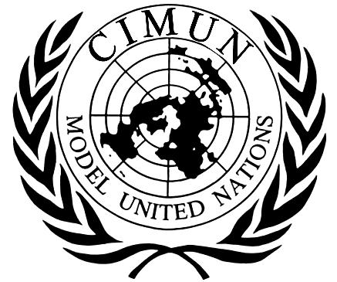
African Union (AU)
Adressing Youth Building Peace Instead of Joining Conflict

Director: Andrea Rojas
Moderator: Lucia Shahani
Secretary: Nicolas Botello

Description of Committee
The African Union (AU) was formally established in 2002, succeeding the Organization of African Unity (OAU) of 1963. The AU was founded to promote unity, peace, security and development in Africa. The vision of the AU is looking for “An integrated, prosperous and peaceful Africa, driven by its own citizens and representing a dynamic force in global arena.” Some of the Objectives of the AU is to defend the sovereignty. The AU aims to protect young people from discrimination, ownership of property and other human rights; ensures freedom of movement, speech, religion, etc. It has a total of 55 member states debating about keeping youth of Africa from gangs, to help them stay in school, and learn how taking the wrong paths can affect them.

Introducción to the Topic
Young people are an important part of youth in Africa nevertheless some young people are caught up in armed conflicts due to poverty, lack of education, unemployment, joining for protection or pressure from armed groups. This is a problem as conflicts take away their safety, education and opportunities. Even teenagers who don’t fight can still be affected by violence. The African Union wants to help young people to be peace builders, not join conflicts. That means giving them opportunities to engage in their communities, to resolve conflict peacefully and to help prevent violence. The African Union says young people should be part of conflict solutions rather than just victims of them. When given the right number of opportunities, and support young people may be able to play an important part on the prevention of conflict and help redirect to promote peace in their communities. Thay can be of great help because of their past experiences, leader shipment skills and ideas to solve them in peacefully and encourage cooperation among different groups.

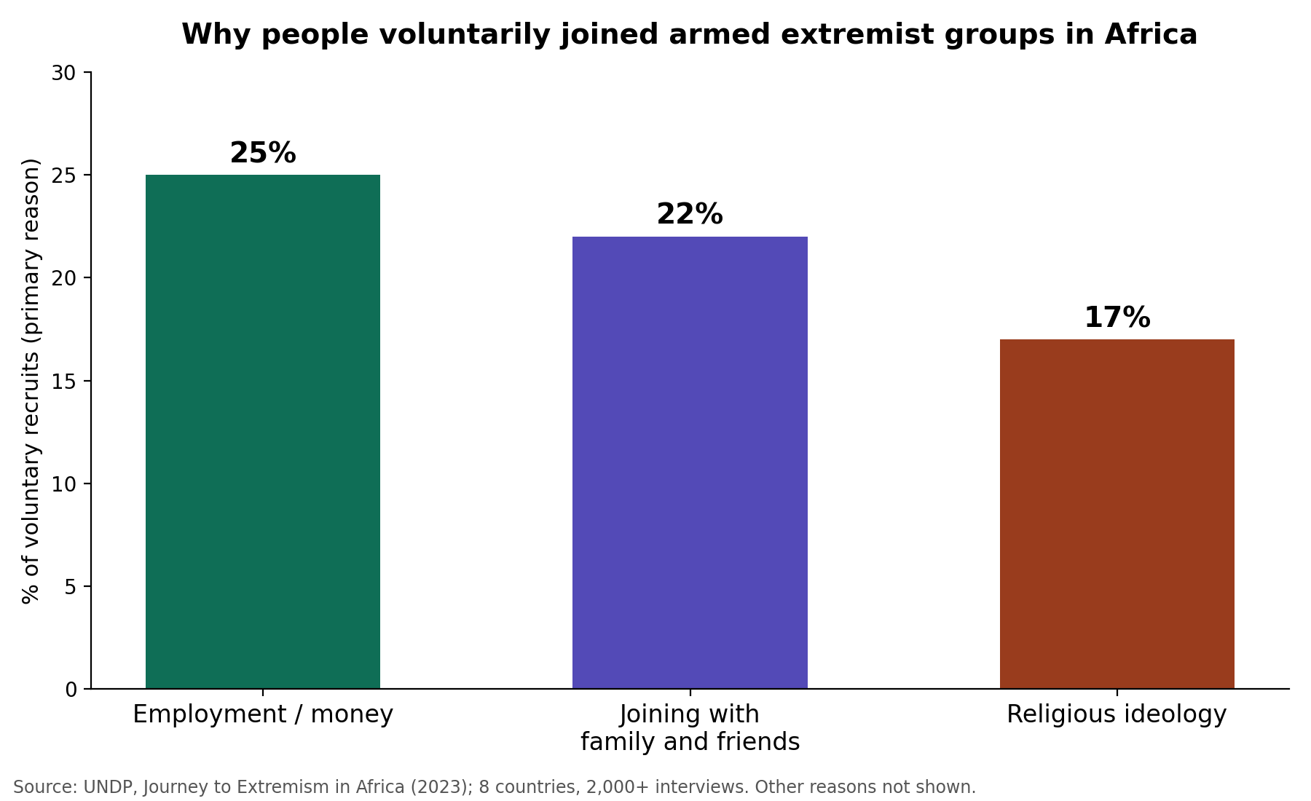

Background Information on the Topic

The African Union (AU) has long been committed to protecting children affected by armed conflict. In 1990, African states adopted the African Charter on the Rights and Welfare of the Child, which safeguards the rights of children, including their protection from the effects of armed conflict. The AU subsequently adopted Africa's Agenda for Children 2040, which establishes targets such as ending the recruitment of children by armed groups and supporting the reintegration of conflict-affected children into their communities. In addition, the AU has established programs and initiatives that expand opportunities for young people to participate in community-level peacebuilding. Through such engagement, the AU seeks to enable young people to become active members of their communities and constructive contributors to peace.

Current Situation
Over the past years the AU has developed several Youth Development Programms (YPS); this has been worked on at a continental level. One of the programs is named the “Youth for Peace Africa Program”. In this program they work to involve young people in promoting peace and security to guide them in creating and maintaining peace. The AU held 5th place in continental dialogue on youth, peace, and security in Burundi in August of 2026. In the meeting it was discussed the role of young people and woman in conflict prevention, peacebuilding, making decisions, and crisis management; this was all meant for strengthening all the actions being taken. The AU is working on finding ways so that they can strengthen young people’s skills and knowledge. In August 2026 the AU launched a new program that brought together young leaders to learn about peace and security, human rights, democratic governance, and responsible leadership. The actions demonstrate that the AU is focusing so that young people may be able to have multiple opportunities they can participate in peacebuilding and help them develop the needed skills to contribute to creating more peaceful communities.

Internalional Action
International actions have been increasing, and they're being led by the United Nations (UN), European Union (EU), and African Union (AU). The UN’s Youth, Peace, and Security (YPS) agenda has been encouraging governments to include young people in discussions and decisions about peace and security through participation, protection, prevention, partnerships, and reintegration. This may be of use for young people to develop leadership, peace-building skills, and become more active in contributing to peace rather than being vulnerable to involvement in conflict. Another recent focus has been to strengthen the cooperation between youth organizations, governments, and other institutions, this is meant so that young people can help defuse conflicts before it comes a more serious situation. The UN and AU have been making some programs that can teach skills such as conflict prevention. These programs can be helpful for so that young people learn how to communicate, manage disagreements, understand other perspectives, and find a peacful solution before getting into conflicts.

Recommendations for Creating aResolution
When writing a resolution, we recommend to focus on reserching on webcites that are reliable and have updated information, this will help you get more recent results and find more accurate solutions. Some webcites that may be of use are the UN’s and AU’s official webcites, in there you may find better results for the information you are looking for. It is also important to compare distinct information from different reliable sources to make sure the information is accurate and relevant to the topic. Avoid the use of Wikipedia as its information may be edited or may be ot always accurate.

Questions to Consider to Create a Resolution
- What can governments or international organizations work together to do to prevent youth involvement in conflict?
- Are there any solutions for young people in conflict affected areas that they can safely participate in peacebuilding?
- What concrete national measures can your country implement to redirect young people from pathways into violence and toward active roles in building peace?
- How can funding and resources be provided to youth organizations working for peace?
- In what ways are young people in your country already involved in conflict?
- When did the government begin to take action or worked to included programmes on youth, peace and security?

Research Aid
https://www.au.int/en
African Committee of Experts on the Rights and Welfare of the Child (ACERWC)
https://data.unicef.org/resources/soac-2025|
https://archive.crin.org/en/home/campaigns/deprivation-liberty/resources/detention-figures/children-detention-justice-system.html

Terms and Concepts
- Prosperous: being successful, thriving, or financially well-off

- Charter: A formal document describing the fundamental principles, rights, or aims of an organization, institution, or country.

- Reintegration: the process of returning something or someone to a unified state or reintroducing them into a group or society

- Youth involvement in conflict: the active participation, recruitment, or impact of young people (typically adolescents and young adults) in situations of violence, war, political unrest, or peacebuilding

- Discrimination: The unjust or prejudicial treatment of different categories of people, especially on the grounds of ethnicity, age, gender, or religion.

- Armed Conflict: A state of open, declared, or active fighting between organized military forces, government troops, or rebel groups.

- Recruitment: The act or process of enlisting or enfolding people, especially young individuals, into armed forces, rebel groups, or gangs.

- Reintegration: The process of helping individuals (such as former youth combatants or gang members) safely return to and settle back into civilian society and their local communities.

References
Youth Development. (2023, May 25). African Union. https://au.int/en/youth-development

About the African Union. (2023, May 25). African Union. https://au.int/en/overview

Kodjo, T. (n.d.). Youth for Peace (Y4P) Africa Programme - African Union - Peace and Security Department. African Union,Peace and Security Department. https://www.peaceau.org/en/page/110-youth-for-peace-africa-programme?utm

Youth, peace and security. (n.d.). Youth Office. https://www.un.org/youthaffairs/en/youth-peace-and-security?utm

2025 Peacebuilding Fund Thematic Review on Youth, Peace and Security. (n.d.). PEACEBUILDING. https://www.un.org/peacebuilding/en/YPS_TR?utm

5th African Union Continental Dialogue on Youth, Peace and Security and Women, Peace and Security to promote inclusive resource governance and peacebuilding in Africa. (2023b, May 25). African Union. https://www.au.int/sw/node/46801?utm

The Peace & Security Council. (2023, May 25). African Union. https://au.int/en/psc

Continental Framework for Youth, Peace and Security. (2023b, May 25). African Union. https://www.au.int/en/documents/20200821/continental-framework-youth-peace-and-security?utm_source

Statement of Dr Alhaji Sarjoh Bah, Director of Conflict Management, on the occasion of the Ministerial and High-Level Open Session on the Promotion and Protection of the Rights and Welfare of Children in Situations of Conflict in Africa. (2023, May 25). African Union. https://au.int/en/speeches/20231204/statement-dr-alhaji-sarjoh-bah-director-conflict-management-occasion-ministerial?utm_source

